Functional
Specification

V 1.0

Training

Components: Login, Dashboard and Create transactions

Author: Hyusein Tyurkmen
Table of Contents

Introduction 3X

Functional requirements 3X

Wireframe diagram 4X
Introduction

This specification describes the part of the “Online bills payment” project which is related to the Login, Dashboard and Create transactions

Functional requirements

When the user go to http://www.onlinebills.com he will see the login page with Username, Password and Login button X

A documentation of Create New Registration will be delivered later.

For valid credentials the user can use username: testuser and password: TestUser1

When a user provides wrong password or username a red colored message:

”Wrong password or username!” appears

When a user provides blank password or username a red colored message:

”A blank password or username is provided!” appears

When the user login successfully he is redirected to the Homepage. See the mockup for more details.

When the user click on Create transaction a confirmation window with OK and Cancel buttons appears

When OK button is clicked a green message: “The transaction is completed” appears

When Cancel button is clicked the confirmation window is closed and the user is turned back to the Homepage

There is a dropdown list with predefined options of choosing a card already registered from the user

When the user clicks Logout a confirmation window appears.

When the user clicks OK to confirm logout its session is killed and the user is redirected to the login page.

When the user clicks Cancel to reject the logout he is landed back to the last visited page
Wireframe diagram

Login form
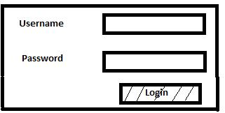

Home page
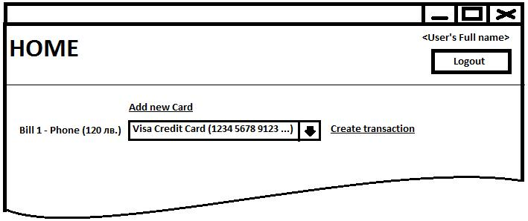

Confirmation dialog
